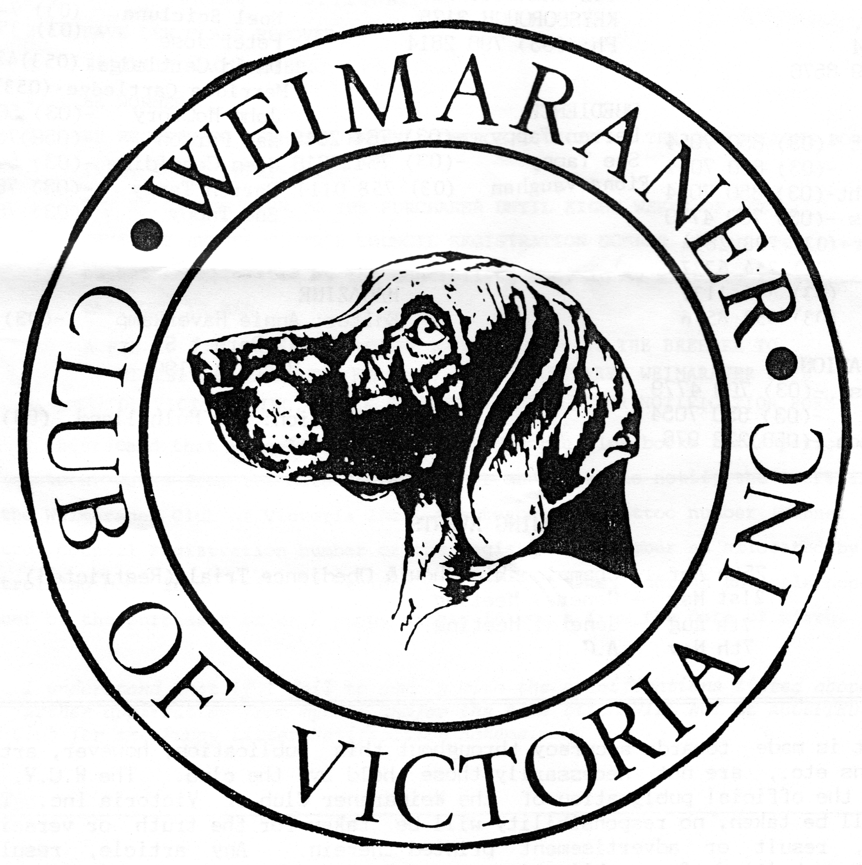  Celebrating 50 Years  1971 - 2021 | WEIMARANER CLUB OF VICTORIA INC.  MERCHANDISE ORDER FORM Ver.3
 | NAME
 | POSTAL ADDRESS |  |  | STREET & NUMBER
 | SUBURB/TOWN |  |  |  |  | STATE | POSTCODE
 | PHONE |  | HOME |  | MOBILE
 | EMAIL
ORDER TOTAL
$

Ordering/Payment Details: Fill in this FORM and send your order along with your payment. Payments can be made by EFT into the following account Weimaraner Club of Victoria Inc. BSB 633-000 Account Number 113428254. Please reference the deposit 'MERCHYOURSURNAME' and include a copy of the EFT receipt with your order.
If you would like your order posted please contact Sharon Sabbatini prior to making payment as Postage and Handling fees apply.
Sharon’s contact details:
Phone 0429 321 473 / 03 53 321473
Email: secretary@weimaranervic.com

CAP | $25
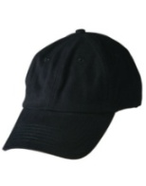 | QUANTITY:
POLOS  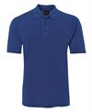 |  | ADULTS |  |  | $35
 |  | Size  Bust/Chest cm  Length cm |  |  | S  53.5  70 |  |  |  |  | M  56  72.5 |  |  |  |  |  |  | L  58.5  75 |  |  |  |  | XL  61  77.5 |  |  |  |  | 2XL  63.5  80 |  |  | 3XL  66.5  81 |  |  |  | 4XL  70  82 |  |  |  |  | 5XL  73.5  83 |  |  |  |  |  | 7XL  89.5  85
 |  | Black
 |  | Maroon
 |  | LADIES |  |  | $35
 |  | Size  Bust/Chest cm  Length cm |  |  | 8  46  62 |  |  |  | 10  48.5  64 |  |  |  |  |  |  | 12  51  66 |  |  |  |  |  | 14  53.5  68 |  |  |  |  | 16  56  70 |  |  | 18  58.5  72 |  |  |  | 20  61  73 |  |  |  |  | 22  63.5  74 |  |  |  |  |  | 24  66  75
 |  | Black
 |  | Purple
POLAR FULL ZIP  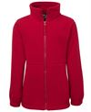 |  | ADULTS |  | $55
 |  | Size  Bust/Chest cm  Length cm |  | S  55  72 |  |  |  |  |  |  |  | M  57.5  74 |  |  |  |  |  |  | L  60  76 |  |  |  |  | XL  62.5  78 |  |  |  | 2XL  65  80 |  |  |  | 3XL  67.5  81 |  |  |  | 4XL  70  82 |  |  |  |  | 5XL  72.5  83
 |  | Black
 |  | Maroon
 |  | Dark Red
 |  | LADIES |  | $55
 |  | Size  Bust/Chest cm  Length cm |  | 8  49  61.5 |  |  |  | 10  51.5  63.5 |  |  |  |  |  |  |  | 12  54  65.5 |  |  |  |  |  | 14  56.5  67.5 |  |  |  |  | 16  59  69.5 |  |  | 18  61.5  71.5 |  |  |  | 20  64  73.5 |  |  |  | 22  66.5  75.5 |  |  |  |  |  | 24  69  77.5
 |  | Black
POLAR VEST  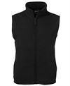 |  | ADULTS |  | $40
 |  | Size  Bust/Chest cm  Length cm |  | S  55  65.5 |  |  |  |  |  |  | M  57.5  67.5 |  |  |  |  |  |  | L  60  62.5 |  |  |  |  | XL  62.5  71.5 |  |  |  |  | 2XL  65  73.5 |  |  |  | 3XL  67.5  75.5 |  |  |  |  | 4XL  70  77.5 |  |  |  |  |  | 5XL  72.5  79.5
 |  | Black
 |  | LADIES |  | $40
 |  | Size  Bust/Chest cm  Length cm |  | 8  49  59.5 |  |  |  | 10  51.5  61.5 |  |  |  |  |  |  | 12  54  63.5 |  |  |  |  |  |  | 14  56.5  65.5 |  |  |  |  | 16  59  67.5 |  |  | 18  61.5  69.5 |  |  |  | 20  64  71.5 |  |  |  |  | 22  66.5  73.5 |  |  |  |  |  | 24  69  75.5
 |  | Black
SOFTSHELL VEST  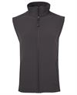 |  |  | ADULT |  |  | $70
 |  |  | Size  Bust/Chest cm  Length cm |  |  | S  54  72 |  |  |  |  |  |  | M  56.5  74 |  |  |  |  |  |  | L  59  76 |  |  |  |  | XL  61.5  78 |  |  |  | 2XL  64  80 |  |  |  | 3XL  66.5  82 |  |  |  | 4XL  69.5  83 |  |  |  |  | 5XL  72  84
 |  |  | Black
 |  |  | Grey
 |  |  | LADIES |  |  | $70
 |  |  | Size  Bust/Chest cm  Length cm |  |  | 6  46  61 | 8  48  63 |  |  |  |  |  |  | 10  50  65 |  |  |  |  |  |  | 12  52  67 |  |  |  |  | 14  54.5  69 |  |  | 16  57  71 |  | 18  59.5  73 |  |  |  | 20  62  75 |  |  |  |  | 22  64.5  77 |  |  |  |  |  | 24  67  79
 |  |  | Black

FLEECE SHEPHERD JACKET  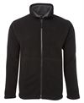 | ADULT | $65
 | Size  Bust/Chest cm  Length cm | S  57.5  72 |  | M  60  74 |  | L  62.5  76 |  | XL  65  78 |  | 2XL  67.5  80 |  | 3XL  70  82
 | Black/Grey
 | Navy/White
 | LADIES | $65
 | Size  Bust/Chest cm  Length cm | 8  48  61 | 10  50.5  63 |  | 12  53  65 |  | 14  55.5  67 |  | 16  58  69 | 18  60.5  71 | 20  63  73
 | Black/ Charcoal
 | Navy/White
FLEECE SHEPHERD VEST  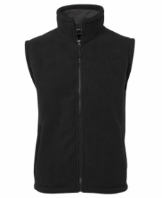 | ADULT | $55
 | Size  Bust/Chest cm  Length cm | S  57.5  72 |  | M  60  74 |  | L  62.5  76 |  | XL  65  78 |  | 2XL  67.5  80 |  | 3XL  70  82
 | Black/Charcoal

FLEECE SHEPHERD HOODIE  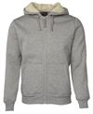 | ADULT | $70
 | Size  Bust/Chest cm  Length cm | S  55  70 | M  57.5  72 | L  60  74 | XL  62.5  76 | 2XL  65  78 | 3XL  67.5  80 | 4XL  70  81 | 5XL  72.5  82
 | Black/ Natural

